CHAPTER 1

Introduction

Chapter 1

Introduction

Natural disasters have devastating consequences, affecting millions of people worldwide. In the aftermath of a disaster, providing timely and efficient relief to affected individuals and communities is crucial. However, traditional relief management systems often face challenges such as inadequate resource allocation, inefficient logistics, and lack of situational awareness. This project proposes the development of an Al-based disaster relief management system, which leverages machine learning and predictive analytics to optimize aid distribution, reduce response times, and improve situational awareness .

The system aims to reduce response times , enhance resources delivery and improves social awareness in disaster response operations . It even helps in understanding the fraud that is taking place and at which level. System makes sure whether resources supplied by distributor are accepted by affected person. Admin is able to understand and has access of distributor as well as affects people.

Aadhar based disaster relief management system helps in building transparency between admin , distributor as well as affected people. By using Aadhar authentication we can exactly achieve all information of that particular affected person as well as he can access this system through Aadhar authentication. It helps in rapid damage assessment , prioritized resource allocation , Real time tracking , optimized route planning , needs assessment , predictive analysis , community engagement , increased transparency and accountability.

Problem identification includes, Fraud and misidentification : Traditional relief distribution methods often suffer from identity fraud, leading to resources being allocated to ineligible individuals. Misidentification can result in vulnerable populations being overlooked during aid distribution. Inefficient Resource Allocation: Delays in identifying beneficiaries and distributing aid can exacerbate the suffering of affected communities. Many existing systems lack real-time data, hindering timely responses. Lack of Coordination: Disparate agencies and organizations often work in silos during disaster response, leading to duplication of efforts or gaps in aid distribution. This lack of coordination can waste resources and diminish the effectiveness of relief efforts.

# CHAPTER 2

## Literature Survey

Chapter 2

Literature Survey

This paper discusses how technology, especially web-based platforms and mobile applications, has become essential in modern disaster management. It emphasizes the role of centralized data collection systems that can streamline communication between disaster response teams, local governments, and affected populations. It argues that integrating technology improves the speed of response and the accuracy of data during emergencies. This paper supports the concept of using a centralized platform (like a website or app) to track and manage disaster relief efforts. The integration of Aadhar into such platforms would improve data accuracy and efficiency in managing aid distribution. [1]

This research delves into how biometric systems, such as fingerprint and facial recognition, can improve the transparency and efficiency of disaster relief efforts. It discusses how biometric technology ensures that the right aid reaches the right person by verifying their identity and preventing fraud or duplication. This paper directly supports the idea of using Aadhar’s biometric system (fingerprints and iris scans) to authenticate victims and ensure that aid is distributed fairly and efficiently. [2]

This paper focuses on Aadhar’s role in e-governance and highlights its application in disaster relief efforts. It explores how Aadhar’s biometric authentication can streamline the identification and verification of beneficiaries during a disaster. It also discusses the challenges related to its use in rural or remote areas, where internet access and technological infrastructure may be lacking. This paper is highly relevant as it directly discusses the application of Aadhar in disaster management, focusing on its benefits for identity verification and aid distribution.[3]

This research paper investigates the concerns regarding privacy and security when using biometric data, particularly in government systems like Aadhar. It discusses the risks associated with large-scale biometric databases and suggests measures to ensure that the data is secure and that privacy is maintained. The paper also explores the ethical issues surrounding biometric data collection and its implications for disaster relief efforts. This paper is valuable for discussing the security and privacy aspects of using Aadhar in disaster relief. It highlights the importance of implementing stringent data protection measures to safeguard personal and biometric data. [4]

This comparative study reviews various disaster management systems, focusing on their technological integration. It compares centralized and decentralized systems and evaluates their effectiveness in terms of data accuracy, transparency, and resource management. The paper highlights that integrated systems provide better control and management of resources, leading to faster relief efforts. This paper provides a foundation for understanding the benefits of a centralized disaster management system, such as the Aadhar-based platform for tracking and verifying aid distribution. [5]

This study explores various digital platforms implemented in India for disaster relief. It provides case studies of how these platforms have been successful in improving the speed and accuracy of relief efforts. The paper discusses how mobile apps and web platforms can be used to track aid distribution, provide real-time updates, and offer communication channels between affected people and relief agencies. This paper supports the development of a website or app for disaster relief and shows how digital platforms can be used for real-time tracking of aid distribution, a core aspect of your project. [6]

This paper discusses how biometric data, particularly from the Aadhar system, can be used not only in disaster response but also in preparedness and mitigation efforts. The study emphasizes that by integrating Aadhar into disaster management systems, authorities can create more effective and proactive disaster preparedness plans by identifying vulnerable populations and ensuring better resource planning. This paper discusses the dual role of Aadhar in both disaster preparedness and relief, supporting the argument that an Aadhar-based system could enhance both aspects of disaster management. [7]

CHAPTER 3

System Specification

CHAPTER 3

System Specification

Software Requirements:

* Database System: MySQL, PostgreSQL, or Firebase for beneficiary and transaction data storage.
* Web Server: Apache or Nginx to serve the web application.
* Backend Development Framework: Java (Spring Boot), Node.js, or Python (Django/Flask) for core application logic and Aadhaar verification.
* Frontend Development Framework: HTML, CSS, JavaScript (React or Angular) for the user interface.
* UIDAI Aadhaar Authentication API Sandbox: For simulating Aadhaar verification.
* Security Protocols: HTTPS for secure data transmission, and data encryption libraries for sensitive information

Hardware Requirements:

* Computer or Cloud Server: To host the central database and application.
* Biometric Device or Scanner: For Aadhaar authentication simulation.
* Tablets or Smartphones: For agents to access the system on the field.

CHAPTER 4

Block Diagram

Chapter 4

Block Diagram

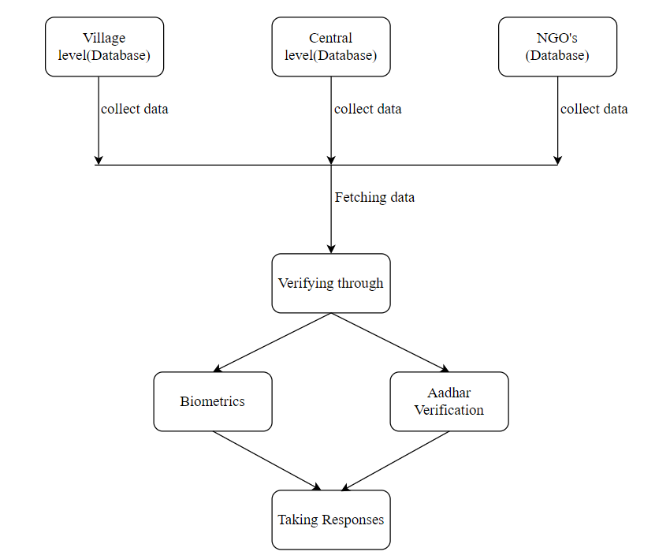

Figure 4.1: Block diagram

CHAPTER 5

System Design

CHAPTER 5

System Design

Data Flow Diagram:

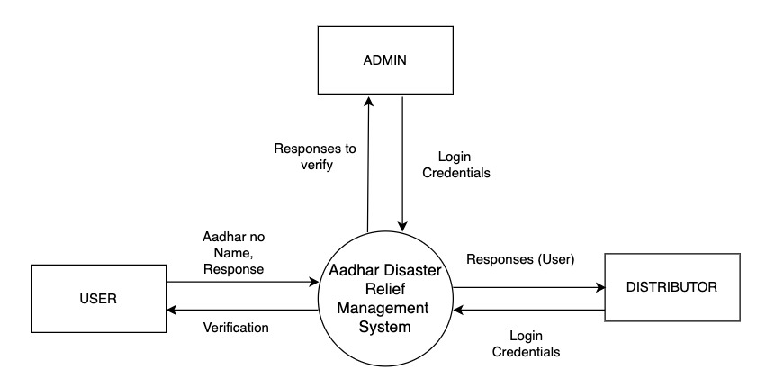

Figure 5.1: DFD Level 0

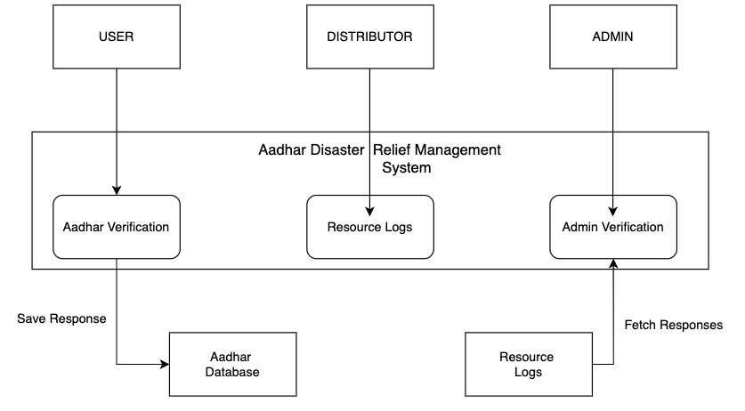

Figure 5.2: DFD Level 1

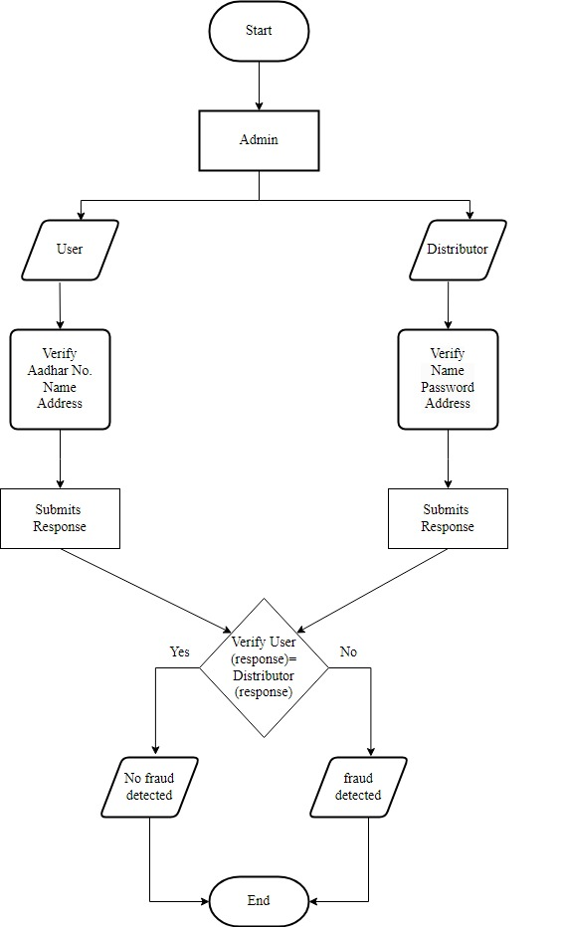

Figure 5.3: Flowchart

UML diagram:

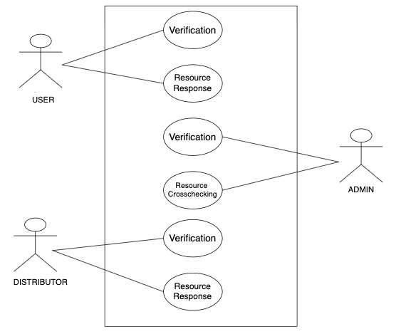

Figure 5.4: Use Case Diagram

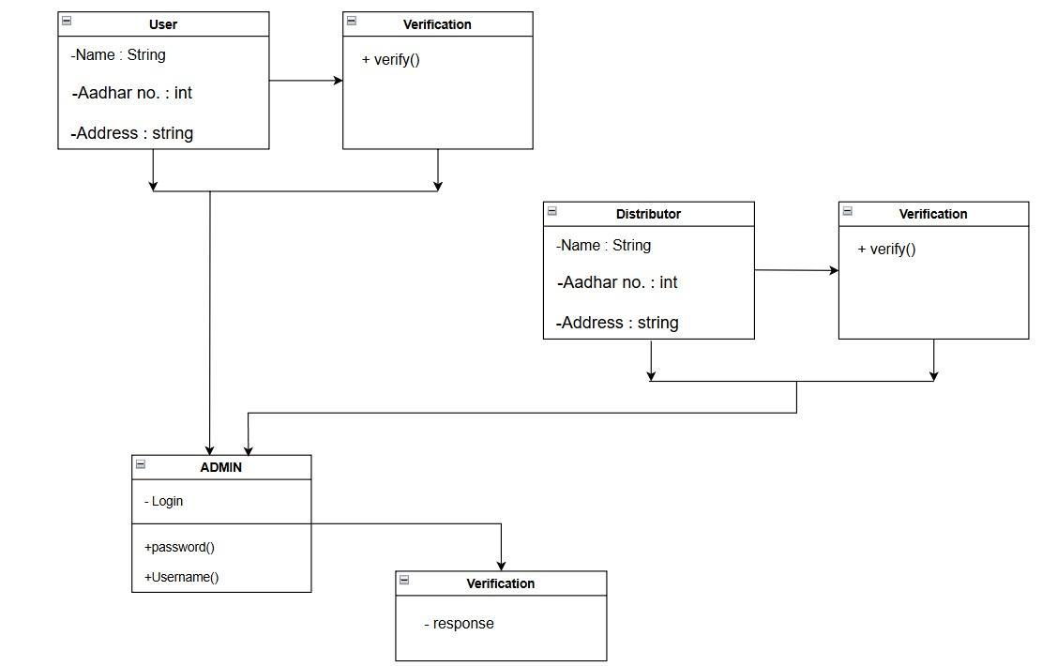

Figure 5.5: Class diagram

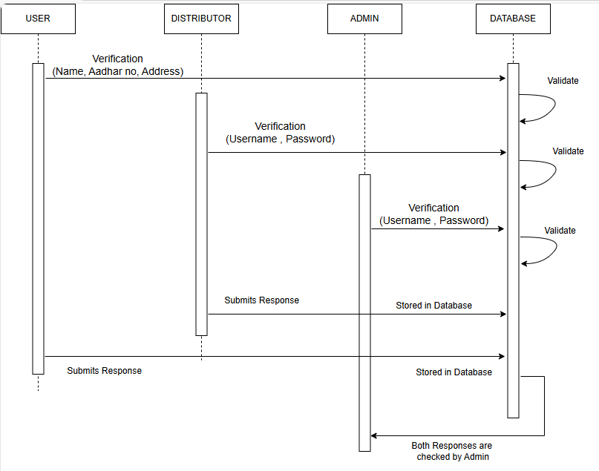

Figure 5.6: Sequence diagram

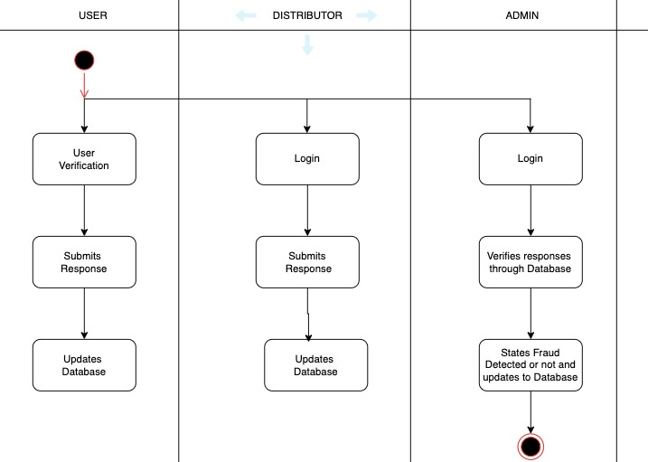

Figure 5.7: Activity diagram

# 

# 

# CHAPTER 6

## Software Development

# CHAPTER 6

## Software Development

Problem statement:

Natural disasters, such as earthquakes, floods, and cyclones, pose a significant threat to human life, infrastructure, and economic stability in India. In the aftermath of a disaster, providing timely and efficient relief to affected individuals and communities is crucial. However, traditional relief management systems often face challenges such as: Inefficient beneficiary identification, inadequate resource allocation, limited transparency and accountability and duplicate or fraudulent claims.

Proposed work**:**

1. Beneficiary Identification: Use Aadhaar for secure and accurate identification of disaster-affected individuals.

2. Centralized Database: Maintain a central record of beneficiaries, resources, and distribution status.

3. Resource Allocation: Allocate and track relief supplies to verified beneficiaries.

4. Efficient Distribution: Automate and streamline aid distribution for faster response.

5. Transparency: Ensure accountability with clear records accessible to authorities.

Future Scope:

1. Resource and Personnel Management: Efficiently allocate resources and coordinate responders to ensure prompt and organized relief efforts.

2. Communication and Public Alerting: Establish reliable communication channels for responders and send alerts to communities about safety measures and evacuations.

3. Post-Disaster Recovery: Track and manage long-term recovery efforts, including infrastructure rebuilding and rehabilitation for affected population.

# CHAPTER 7

## Troubleshooting / Debugging

CHAPTER **7**

**Troubleshooting / Debugging**

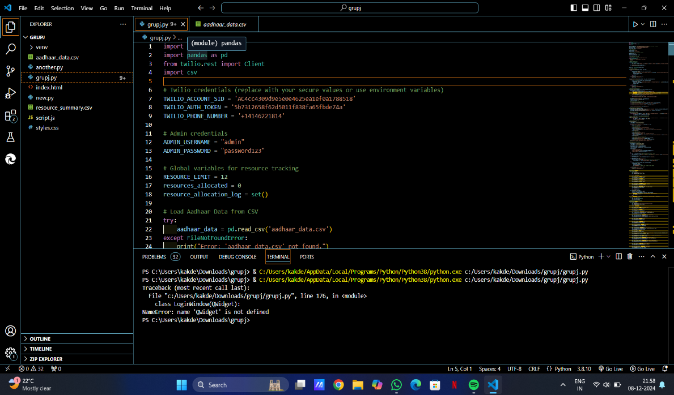

The error message NameError: name 'QWidget' is not defined occurred when executing the code. To resolve this error I have imported libraries like PyQt5.

**Code after resolution of problem:**

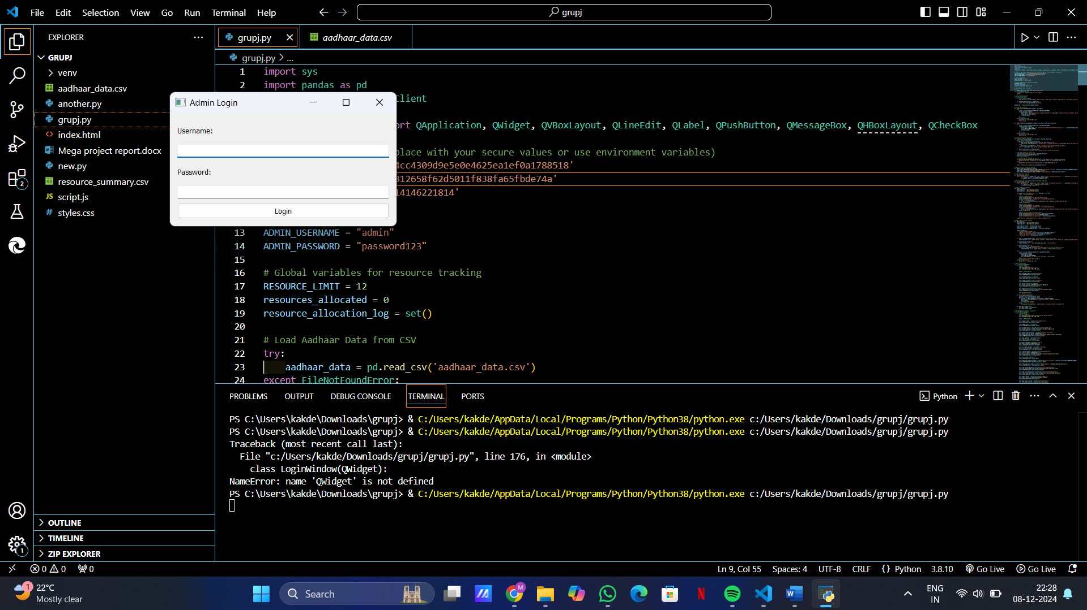

# CHAPTER 8

Conclusion

CHAPTER 8

## **Conclusion**

The proposed Aadhar-based disaster relief management system has the potential to revolutionize the way disaster relief is delivered in India. Similar to the success of other Aadhaar-based systems in addressing societal challenges, our project aspires to provide a robust framework for quick and fair relief distribution during crises. By leveraging the unique digital identity provided by Aadhar, the system can streamline beneficiary identification, optimize resource allocation, enhance transparency and accountability, and prevent duplicate or fraudulent claims . Key advantages would be improved efficiency and effectiveness in disaster relief delivery and better targeting of relief resources to those who need it most.

In this semester, we have focused on the foundational aspects of the system. This includes: Requirement analysis and research, system design, Backend development, Prototyping.

For the next semester, our objectives are: Fingerprint Authentication, Frontend Development, Integration of Real-time Features, Collaboration with UIDAI, Implementation of Advanced Analytics, Testing and Refinement, Deployment and Feedback Collection.

# CHAPTER 9

References

## CHAPTER 9

## **REFERENCES**

1. Sharma, A., & Gupta, R. (2020). *Technology Integration in Disaster Management: Enhancing Efficiency and Response*. International Journal of Disaster Risk Reduction, 48, 101622.
2. Kumar, S., & Patel, D. (2019). *Biometric Solutions for Aid Verification in Disaster Management*. Journal of Humanitarian Logistics and Supply Chain Management, 9(3), 329-345.
3. Verma, M., & Singh, T. (2021). *Aadhar's Role in E-Governance and Disaster Relief Management*. Asian Journal of Public Administration, 43(1), 85-102.
4. Ahmed, I., & Khan, N. (2022). *Biometric Data Security and Privacy Challenges in Public Systems*. Information Systems Security, 31(4), 401-416.
5. Chatterjee, S., & Banerjee, R. (2020). *Comparative Analysis of Global Disaster Management Systems*. Journal of Disaster Research, 15(5), 653-664.
6. Joshi, P., & Mehta, S. (2019). *Digital Platforms in Disaster Relief: Case Studies from India*. Journal of Information Technology & Politics, 16(4), 387-403.
7. Rao, V., & Pillai, A. (2023). *Enhancing Disaster Preparedness through Biometric Data Integration: The Case of Aadhar*. International Journal of Public Sector Management, 36(2), 275-289.